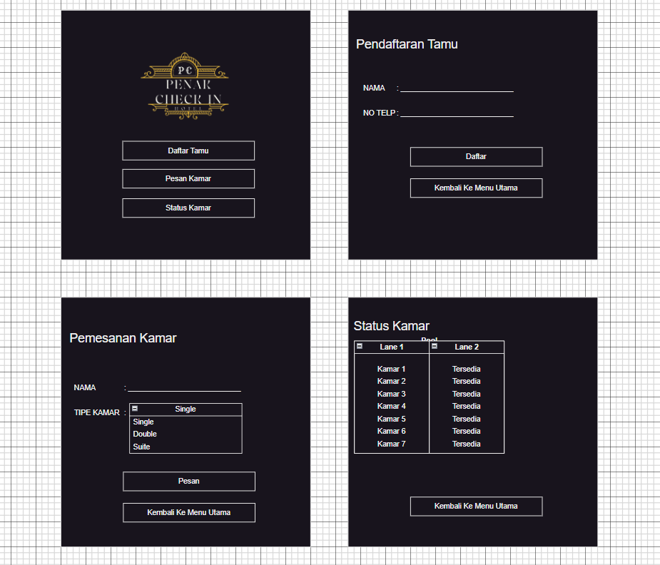

Kelompok 2

1. Azzun Adna (A710230017)
2. Nabira Zain ( A710230008)
3. Muhammad Iqbal A (A710230005)
4. Abi Yudistira (A710230012)